**Clash Royale Update**

* I am playing [Clash Royale](https://clashroyale.com/) since 2016. When Clash Royale was released,it was so much popular. Now-a-days it losing it's popularity. But not that much. Because of their developers. The developers of the game trying their heart and soul for the game. They are updating the game every month. Releasing new cards,new game mode etc.

[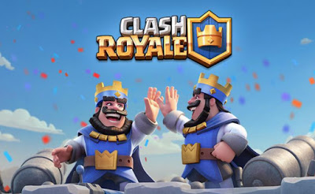](https://4.bp.blogspot.com/-yN6RXsVBgj0/W84QOXmlO8I/AAAAAAAAAZc/k0hF-LOASPwzmbxGrf_8EQhXnYTUoIbcACEwYBhgL/s1600/Clash-Royale-2B-Revenue.jpg)

Their last big update was war mode and card trading system. Since these two update, popularity of the game again increased. It has changed the overview of the game totally and again it's in the top chart. Their last update was yesterday 10/01/02018. It was a balance update. They announced there will be a balance update in every month's first week, for the betterment of the game. This will make the player playing the game more smoothly. Let's see what changes this balance update did to the game.

**Balance Update 10/1**

* **Royale Giant:** Since the release of the game, Royale Giant is most confusing card for the players and for the developers. Some time it get's buffed then after some month it gets nerfed. It's range was a big issue. Before yesterday's update it could hit any building from a massive distance. But from now it won't.

[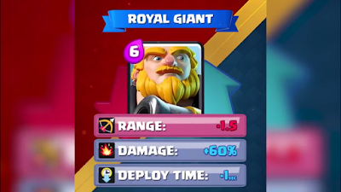](https://4.bp.blogspot.com/-Vk8qrnoFQzE/W7Mvgx_m_6I/AAAAAAAAAF0/jFpbkG0DRSsLq-QZ_RqwNPfOnM87qpQfwCLcBGAs/s1600/Screenshot_2018-10-01-22-04-58.png)

It's range has been reduced from **6.5** tiles to **5** tiles. Now building cards like Canon,Inferno    Tower,Bomb Tower can also hit Royale Giant. For it's range issue Queen Tower will now have more  hit. But developers buffed it's damage. And it's a huge change. Now it will break down queen towers and King Tower so much faster. It's damage increased **60%**. It's deploy time also reduced from **2sec** to **1sec**. In my opinion, at this moment I don't have any idea of it being nerfed or buffed.

* **Goblin Giant:** It is recently released card that's why Supercell still working on it. For more use Supercell increased it's hitpoints **6%**. From now on it will survive more time on the arena.

[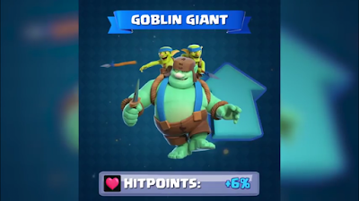](https://4.bp.blogspot.com/-wl6S5BX_hCU/W7M2EaxPfqI/AAAAAAAAAGA/r7xoLNG0J0MBb3vju7M8Xso4iOEkEWtPACLcBGAs/s1600/Screenshot_2018-10-01-22-09-45.png)

* **Bomb Tower:** When I was a noob it was one of my favourite card. Reason was for it's area damage. i used to keep it in my every single deck. It was damn useful in the lower arena. Now it gets buffed again.

[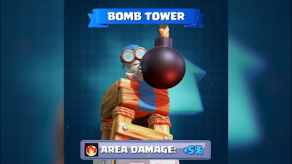](https://2.bp.blogspot.com/-HuFseisbAQI/W7M3NJCMD6I/AAAAAAAAAGM/LPqYsh2V-Xkn8MlHWYQmEWCkhdC3OXregCLcBGAs/s1600/Screenshot_2018-10-01-22-10-43.png)

It's area damage is increased by **5%**. Now on it will do more damage on the troops. It will also play a vital role as defending building. Those who gave up this card like me should be back. Now it is more useful than before.

* **Goblin Hut:** One of the most irritating card from my point of view. In last update it was nerfed. And now guess what!! It's Back again.

[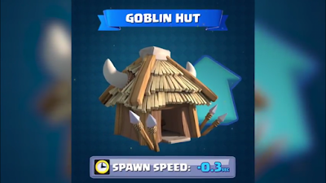](https://1.bp.blogspot.com/-Fh19A_JQuKs/W7M4luuEuQI/AAAAAAAAAGY/SDsrxWQvcO8id9rzDeNWHXOKxcYZVt2OQCLcBGAs/s1600/Screenshot_2018-10-01-22-11-15.png)

The goblin spawn speed is decreased to 3%. It means now Goblin Hut will produce one extra goblin. Which will irritate player like me.

* **Skeletons:** Larry is back! Yes he is. From the release, it is developers favourite card (Don't know the real truth). Sometime they reduce one skeleton from skeleton army and skeletons which is 01 elixir card. Sometime they bring the skeleton back again.

[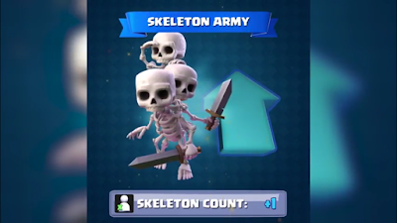](https://3.bp.blogspot.com/-_3X2OvEbpG4/W7M6uIYLxGI/AAAAAAAAAGk/6OW9BFcgLjMk5WXzmompK6S4M8pPkyATgCLcBGAs/s1600/Screenshot_2018-10-01-22-11-49.png)

Now it's Larry's returning time. He is back in the skarmy and also with his three skeleton friends. And ready for doing more damage.

* **Barbarian Barrel:** This card never was on my favourite list. I just didn't like it though it's useful. Supercell buffing it for more using. Now it will **roll like lo**g. Yes it's getting log's speed. That's interesting.

[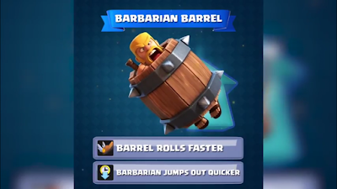](https://1.bp.blogspot.com/-HvamnQyI6Ew/W7M75h7aPAI/AAAAAAAAAGw/JLa0SXpY60smE702E-7lspHMv40bdVNggCLcBGAs/s1600/Screenshot_2018-10-01-22-12-57.png)

Another thing Barbarian will now jumps out quicker and can go for battle. I think this card will be more useful now on.

* **Snowball:** It is one of the card that released recently. It's a 02 elixir cost spell. I didn't find it that much useful. But it's not me to concern. I am a player like you. Now Supercell buffing it for player like me who didn't find this card useful.

[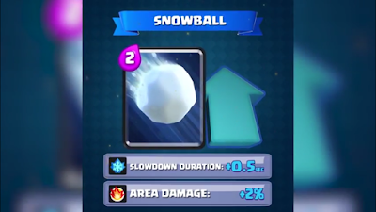](https://4.bp.blogspot.com/-eoKZXIY5R8E/W7M9JoLr-0I/AAAAAAAAAG8/qSTzkyuWRd4Oj4C1bI1UPSt4HKVXxCEbwCLcBGAs/s1600/Screenshot_2018-10-01-22-15-24.png)

Developers increasing it's slowdown duration by **0.5sec.** Also increasing it's area damage by **02%**. Now it will be a concern of me and everybody who didn't like it that much.

* **Ice Wizard:** Most favourite card of mine but not everyone's. My Ice wizard is level 12. I like it for it's capability of slowing down troops speed with ice while dealing little bit damage. Now it's getting buffed. It was most player choice from twitter vote.

[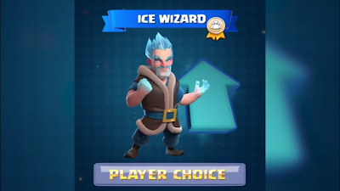](https://4.bp.blogspot.com/-lCb9HIPsUTU/W7M-4O5doCI/AAAAAAAAAHI/BGg8FVoB9GQm3FXWzpatdqlmNRjaPffvACLcBGAs/s1600/Screenshot_2018-10-01-22-13-22.png)

[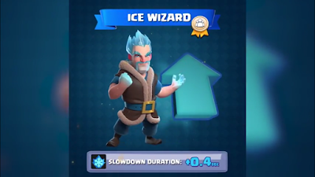](https://3.bp.blogspot.com/-cujEjd6bJOI/W7M_YJQDnnI/AAAAAAAAAHY/KKpro2ME5J8TOIMLPVJNViVTkFGQF_SsQCLcBGAs/s1600/Screenshot_2018-10-01-22-13-52.png)

It's slowdown speed increased by **0.4%**. Now it will be more useful to every player.

That's all of the Balance Update 10/1. I hope you liked it. Leave a comment if there is something more informative or wrong in my post. Thank You.